# Cs-340 Project Two README

## About the Project/Project Title

*This application allows for the effective and efficient utilization of a database of animals (AAC) to search and filter the database with the needed and specific data we need to utilize. We can utilize filters for data and other related information to view in-depth statistics including geolocation graphing, user interaction, and charts related to the data we have encountered.*

## Motivation

*This program was developed mainly to test and manipulate databases using Python as the main language to manipulate MongoDB. Python is a basic language that can be easily modified and integrates very effectively with MongoDB. Python can be utilized within Jupyter Notebook and other various integration methods to work as effectively and efficiently as possible.*

## Getting Started

1. *Open python console and enter MongoDB*
2. *Import your file such as aac_shelter_outcome.csv*
3. *Parse and sift through the related data throughout the csv file and verify the data is parsed correctly.*
4. *The user must create both an admin account and a user account such as aacuser to access various parts of the database.*
5. *Install Python and Jupyter Notebook to utilize the Python integration within the program*
6. *Utilize Python coding to manipulate data within the Notebook and connect to the database with the related information and user accounts.*

## Installation

1. *Latest version of Python*
2. *MongoDB*
3. *Jupyter Notebook*
4. *IDE such as Visual Studio Code*

## Usage

*Use this space to show useful examples of how your project works and how it can be used. Be sure to include examples of your code, tests, and screenshots.*

### Code Example

* *Running DASH for visualization purposes:*

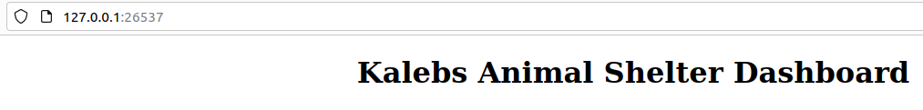

* Utility functions to utilize throughout the implementation:

### Tests:

* Created a new animal for testing purposes

* Updating information related to an animal

* Deleting an animal already created

### Screenshots:

## Contact

Kaleb Ward